2026 Emergency Action Plans for Nebraska Extension Offices/Units
1. What is an EAP?
EAP stands for Emergency Action Plan. Departments and units on campus are expected to review their EAPs annually, and county Extension offices are highly encouraged take part in this initiative through a collaboration between Nebraska Extension and UNL’s Office of Emergency Management. The goal of an EAP is to outline procedures and information that could be used by staff in the event of an emergency. Information includes office location description, shelter-in-place/evacuation procedures, and staff contact information, among other important information.
2. Should my office/unit complete an EAP for 2026?
Yes! All offices are highly encouraged to do it and you’ll find the support you need along the way. The 2026 EAP Template was shared in an email. Campus is working on “internal portals” on websites but until then, these resources will still be available on the disaster.unl.edu website. Go to “About Us” and Employee Resources. You can also contact Soni Cochran, scochran2@unl.edu if you need a copy of the template.
Some offices/units have offices in multiple locations. If your office/unit has an office in several locations - each office will need an EAP.
3. Updated resources – Use the newest template! Since 2022, the EAP templates reflect Extension’s Engagement Zone model. Another change is that in places where text is updated by your office, the font color is now Blue. The Blue Text will make it easier for a reviewer or others to read your plan. Please retain the blue font. (Note: A switch was made to Blue because the red was too low of a contrast to meet accessibility standards.)
If your current EAP uses an older template (prior to 2023), please use the new template.
4. Who should take the lead on the EAP in my office?
It is up to you! Information has been shared in Keeping Up and an email will be sent to everyone in the Engagement Zones within the submission window. Discuss update plans at a staff meeting. This is a good opportunity to delegate the responsibility to an individual who enjoys planning and details. Everyone in the office should be invited to provide input and become familiar with the plan.
5. How long will it take to develop or update our office EAP? The time to complete a plan will vary depending on the office, but it is anticipated that 1-2 hours is sufficient. Putting together the plan’s attachments, like an office drawing or map, may require more time. If you are updating your plan, expect around 30 minutes to one hour.
6. Will my office be recognized if we complete an EAP? In addition to the good feeling you’ll get from completing an EAP, your office will be recognized on social media, in news releases, and in impact reports.
TIP: If you use PEARS for reporting, Emergency Action Plans included as outcomes for the Nebraska EDEN State Action Plan. Copy the state plan as one of your Individual Action Plans so you can report your efforts as a member of Nebraska EDEN.
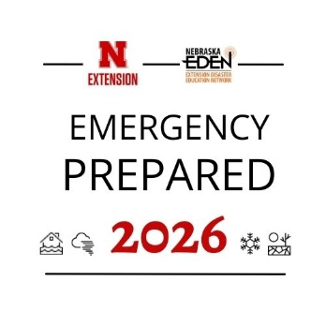
7. To whom do I send my office’s completed EAP? Upload your completed EAP for review using the Qualtrics submission form: https://go.unl.edu/countyofficeeap Use this link any time you have a change in your plan (examples: someone is new to the office, leaves or retires, changes to your facility). Please do not email your EAP directly to Soni Cochran, use the Qualtrics form.
8. After I send in the EAP, what happens to it? Your plan will be reviewed, and constructive feedback may be provided. Once the plan is finalized, it is stored in a protected folder on SharePoint and shared with UNL’s Office of Emergency Management and your Engagement Zone Coordinator. Also, once the plan is finalized, it is up to you and your office staff to determine how to access your plan locally and securely (i.e. Teams, print copies, etc.).
Do not post the EAP on a publicly-accessible website. EAPs may contain personal information.
9. I still have questions. Who can I reach out to?
For questions about the office/unit EAP, contact Soni Cochran, Nebraska Extension Disaster Education Coordinator, scochran2@unl.edu
There will also be office hours scheduled for anyone to ask questions and review the EAP and submission process. These opportunities will be announced in an email to the zones during their assigned review and submission window.
10. Practice Your EAP often. The best way for you to find out if your EAP “works”, is to practice your plan. Hold a fire drill, tornado drill, communications drill - discuss your plan at a staff meeting. These drills and discussions should be done during blue skies. During an emergency event, what you practice could save lives.
Updated January 2026

